STAGE 0.5: COLUMN OPTIMIZATION & ANALYTICAL RELEVANCE FILTERING

## Complete A‑to‑Z Error Enumeration & Resolution Specification
### For Educational Dataset Analysis (ReadyNest Context)

---

## OBJECTIVE

Optimize the dataset by identifying and processing columns based on their **analytical relevance**, **data quality**, and **business value**. This stage ensures that only meaningful, analysis-ready columns proceed to the cleaning pipeline.

**Stage 0.5 is a pre-processing optimization stage.**
**Stage 0.5 analyzes actual data content, not just column names.**
**Stage 0.5 makes informed decisions: KEEP, FLAG, or DROP.**

---

## CORE PRINCIPLES

| Principle | Rule |
| :--- | :--- |
| **Never Trust Column Names** | Always analyze the actual data inside |
| **Business Context Matters** | Only keep columns relevant to business goals |
| **Data Quality Drives Decisions** | Empty, redundant, or low-quality columns are dropped |
| **Preserve Potential Value** | Flag questionable columns for review first |
| **Reduce Processing Overhead** | Drop columns that add no analytical value |
| **Document Every Decision** | Log why each column was kept, flagged, or dropped |
| **Configurable Rules** | Rules should be adjustable as business needs evolve |

---

# SECTION 1: COLUMN CLASSIFICATION SYSTEM

## 1.1 Classification Categories

| Category | Description | Action |
| :--- | :--- | :--- |
| **Essential** | Critical for analysis | ✅ Keep |
| **Analytical** | Valuable for insights | ✅ Keep |
| **Optional** | May be useful | ⚠️ Flag for review |
| **Redundant** | Duplicate information | ❌ Drop |
| **Irrelevant** | No business value | ❌ Drop |
| **Vague** | Unclear meaning/usage | ⚠️ Flag for review |
| **Empty** | No data or all null | ❌ Drop |
| **Low Quality** | Poor data quality | ⚠️ Flag for review |

---

## 1.2 Business Goals for ReadyNest

ReadyNest sells courses and internships to colleges. Therefore, the dataset must help answer:

| Business Question | Required Columns |
| :--- | :--- |
| **Which courses are most popular?** | Course, Branch, Semester, Student Count |
| **Which branches have highest enrollment?** | Branch, Course, Student Count |
| **What is the student performance trend?** | Marks, CGPA, Attendance, Semester |
| **Which students are at risk?** | Marks, CGPA, Attendance, Backlogs, Status |
| **What is the demographic profile?** | Age, Gender, City, State |
| **Who to contact for placements?** | Email, Phone, Student Name, Student ID |

---

# SECTION 2: COLUMN DECISION CRITERIA

## 2.1 Data Population Analysis (Emptiness Thresholds)

| Non-Empty % | Category | Action | Confidence |
| :--- | :--- | :--- | :--- |
| **> 95%** | Excellent | ✅ KEEP | 100% |
| **80-95%** | Good | ✅ KEEP | 95% |
| **60-80%** | Acceptable | ✅ KEEP (flag if low quality) | 80% |
| **50-60%** | Marginal | ⚠️ FLAG for review | 60% |
| **30-50%** | Poor | ⚠️ FLAG for review | 40% |
| **5-30%** | Very Poor | ⚠️ FLAG for review (consider drop) | 30% |
| **< 5%** | Nearly Empty | ❌ DROP | 90% |
| **0%** | Completely Empty | ❌ DROP | 100% |

---

## 2.2 Data Cardinality Analysis

| Distinct Values | Category | Action | Confidence |
| :--- | :--- | :--- | :--- |
| **Many distinct** | High Variation | ✅ KEEP | 100% |
| **5-10 distinct** | Moderate Variation | ✅ KEEP | 90% |
| **3-5 distinct** | Low Variation | ⚠️ FLAG for review | 60% |
| **2 distinct** | Very Low Variation | ⚠️ FLAG for review | 50% |
| **1 distinct** | No Variation | ❌ DROP (no analytical value) | 90% |
| **0 distinct** | Empty | ❌ DROP | 100% |

---

## 2.3 Data Type Analysis

| Data Type | Category | Action | Confidence |
| :--- | :--- | :--- | :--- |
| **Numeric** | Analysis-ready | ✅ KEEP | 100% |
| **Date/Time** | Analysis-ready | ✅ KEEP | 100% |
| **Text (Categorical)** | Analysis-ready | ✅ KEEP | 100% |
| **Text (Free-form)** | May be useful | ⚠️ FLAG for review | 70% |
| **Mixed Data Types** | Poor quality | ⚠️ FLAG for review | 50% |
| **Binary (Yes/No)** | Useful for classification | ✅ KEEP | 90% |
| **Formula/Calculated** | May be redundant | ⚠️ FLAG for review | 60% |

---

## 2.4 Correlation Analysis

| Correlation with Target | Category | Action | Confidence |
| :--- | :--- | :--- | :--- |
| **High Correlation** | Strong predictor | ✅ KEEP | 100% |
| **Moderate Correlation** | Weak predictor | ✅ KEEP | 80% |
| **Low Correlation** | Minimal predictor | ⚠️ FLAG for review | 60% |
| **No Correlation** | Not useful | ❌ DROP | 90% |
| **Negative Correlation** | Inverse relationship | ✅ KEEP | 90% |

---

## 2.5 Business Value Analysis

| Business Value | Category | Action | Confidence |
| :--- | :--- | :--- | :--- |
| **Directly helps goals** | High Value | ✅ KEEP | 100% |
| **Indirectly helps goals** | Medium Value | ✅ KEEP | 80% |
| **May help goals** | Low Value | ⚠️ FLAG for review | 60% |
| **No business value** | No Value | ❌ DROP | 100% |

---

# SECTION 3: COMPLETE COLUMN DECISION MATRIX

## 3.1 Decision Matrix Summary

| Criteria | Decision | Confidence |
| :--- | :--- | :--- |
| **Essential Column** | ✅ KEEP | 100% |
| **Analytical Column + Good Data Quality** | ✅ KEEP | 100% |
| **Analytical Column + Poor Data Quality** | ⚠️ FLAG for review | 60% |
| **Redundant Column** | ❌ DROP | 100% |
| **Empty Column (>95% empty)** | ❌ DROP | 100% |
| **Irrelevant Column** | ❌ DROP | 100% |
| **Vague Column + Low Business Value** | ❌ DROP | 80% |
| **Vague Column + Possible Business Value** | ⚠️ FLAG for review | 50% |

---

## 3.2 Action Matrix

| Data Population | Cardinality | Business Value | Data Type | Decision |
| :--- | :--- | :--- | :--- | :--- |
| > 95% | Many | High | Numeric/Date | ✅ KEEP |
| > 95% | Many | High | Text | ✅ KEEP |
| > 95% | Few | High | Numeric/Date | ✅ KEEP |
| 60-95% | Many | High | Any | ✅ KEEP |
| 60-95% | Few | High | Any | ⚠️ FLAG |
| 30-60% | Many | High | Any | ⚠️ FLAG |
| 30-60% | Few | High | Any | ⚠️ FLAG |
| 5-30% | Any | Any | Any | ⚠️ FLAG |
| < 5% | Any | Any | Any | ❌ DROP |
| 0% | 0 | None | Empty | ❌ DROP |
| Any | 1 | Low | Any | ❌ DROP |
| Any | Redundant | None | Any | ❌ DROP |

---

# SECTION 4: COLUMN ANALYSIS CASES (Complete Catalogue)

## CASE 1: Completely Empty Column

### Possible Problems
| Column Name | Issue |
| :--- | :--- |
| `Column1` | All rows empty |
| `Analysis` | All rows empty |
| `Unnamed: 0` | All rows empty |
| `(blank)` | All rows empty |
| `NULL` | All rows empty |
| `Temp` | All rows empty |

### Our Approach
1. Count non-null values per column
2. If 0% non-empty → ❌ Drop immediately

**Resolution Examples:**
| Column | Non-Empty % | Action | Confidence |
| :--- | :--- | :--- | :--- |
| `Column1` | 0% | ❌ Drop | 100% |
| `Analysis` | 0% | ❌ Drop | 100% |
| `Unnamed: 0` | 0% | ❌ Drop | 100% |

---

## CASE 2: Mostly Empty Column (< 5% Non-Empty)

### Possible Problems
| Column Name | Non-Empty % | Issue |
| :--- | :--- | :--- |
| `Notes` | 2% | Mostly empty |
| `Comments` | 3% | Mostly empty |
| `Remarks` | 4% | Mostly empty |
| `Feedback` | 1% | Mostly empty |

### Our Approach
1. If non-empty % < 5% → ❌ Drop
2. Unless column is identified as critical

**Resolution Examples:**
| Column | Non-Empty % | Action | Confidence |
| :--- | :--- | :--- | :--- |
| `Notes` | 2% | ❌ Drop | 90% |
| `Comments` | 3% | ❌ Drop | 90% |
| `Remarks` | 4% | ❌ Drop | 90% |

---

## CASE 3: Very Poor Data Quality (5-30% Non-Empty)

### Possible Problems
| Column Name | Non-Empty % | Issue |
| :--- | :--- | :--- |
| `Fees_Paid` | 25% | Mixed data, many empty |
| `Backlogs` | 20% | Many empty |
| `Guardian_Name` | 15% | Many empty |
| `Blood_Group` | 10% | Many empty |

### Our Approach
1. Check business value
2. If high value → ⚠️ Flag for review
3. If low value → ❌ Drop

**Resolution Examples:**
| Column | Non-Empty % | Business Value | Action | Confidence |
| :--- | :--- | :--- | :--- | :--- |
| `Fees_Paid` | 25% | High (Financial) | ⚠️ Flag | 60% |
| `Backlogs` | 20% | High (Academic) | ⚠️ Flag | 60% |
| `Guardian_Name` | 15% | Medium | ⚠️ Flag | 50% |
| `Blood_Group` | 10% | Low | ❌ Drop | 80% |

---

## CASE 4: Poor Data Quality (30-50% Non-Empty)

### Possible Problems
| Column Name | Non-Empty % | Issue |
| :--- | :--- | :--- |
| `Address` | 45% | Many empty |
| `Alternate_Phone` | 40% | Many empty |
| `Internship_Company` | 35% | Many empty |
| `Project_Details` | 30% | Many empty |

### Our Approach
1. Check business value
2. If high value → ⚠️ Flag for review
3. If low value → ❌ Drop

**Resolution Examples:**
| Column | Non-Empty % | Business Value | Action | Confidence |
| :--- | :--- | :--- | :--- | :--- |
| `Address` | 45% | Medium | ⚠️ Flag | 60% |
| `Alternate_Phone` | 40% | Low | ❌ Drop | 70% |
| `Internship_Company` | 35% | High | ⚠️ Flag | 60% |
| `Project_Details` | 30% | Low | ❌ Drop | 70% |

---

## CASE 5: Marginal Data Quality (50-60% Non-Empty)

### Possible Problems
| Column Name | Non-Empty % | Issue |
| :--- | :--- | :--- |
| `CGPA` | 55% | Many empty |
| `Attendance` | 58% | Many empty |
| `Marks` | 52% | Many empty |
| `Category` | 50% | Many empty |

### Our Approach
1. Check business value
2. If high value → ✅ Keep (impute in Stage 9)
3. If low value → ⚠️ Flag for review

**Resolution Examples:**
| Column | Non-Empty % | Business Value | Action | Confidence |
| :--- | :--- | :--- | :--- | :--- |
| `CGPA` | 55% | High (Performance) | ✅ Keep | 80% |
| `Attendance` | 58% | High (Engagement) | ✅ Keep | 80% |
| `Marks` | 52% | High (Performance) | ✅ Keep | 80% |
| `Category` | 50% | Medium | ⚠️ Flag | 60% |

---

## CASE 6: Acceptable Data Quality (60-80% Non-Empty)

### Possible Problems
| Column Name | Non-Empty % | Issue |
| :--- | :--- | :--- |
| `Email` | 75% | Some empty |
| `Phone` | 70% | Some empty |
| `City` | 72% | Some empty |
| `State` | 68% | Some empty |

### Our Approach
1. Check business value
2. If high value → ✅ Keep
3. If low value → ⚠️ Flag for review

**Resolution Examples:**
| Column | Non-Empty % | Business Value | Action | Confidence |
| :--- | :--- | :--- | :--- | :--- |
| `Email` | 75% | High (Contact) | ✅ Keep | 95% |
| `Phone` | 70% | High (Contact) | ✅ Keep | 95% |
| `City` | 72% | Medium | ✅ Keep | 80% |
| `State` | 68% | Medium | ✅ Keep | 80% |

---

## CASE 7: Good Data Quality (80-95% Non-Empty)

### Possible Problems
| Column Name | Non-Empty % | Issue |
| :--- | :--- | :--- |
| `Name` | 92% | Some empty |
| `Course` | 90% | Some empty |
| `Branch` | 88% | Some empty |
| `Semester` | 85% | Some empty |

### Our Approach
1. ✅ Keep all high-value columns
2. Fill missing values in Stage 9 (Imputation)

**Resolution Examples:**
| Column | Non-Empty % | Action | Confidence |
| :--- | :--- | :--- | :--- |
| `Name` | 92% | ✅ Keep | 100% |
| `Course` | 90% | ✅ Keep | 100% |
| `Branch` | 88% | ✅ Keep | 100% |
| `Semester` | 85% | ✅ Keep | 100% |

---

## CASE 8: Excellent Data Quality (> 95% Non-Empty)

### Possible Problems
| Column Name | Non-Empty % | Issue |
| :--- | :--- | :--- |
| `Student_ID` | 100% | Complete |
| `Name` | 98% | Almost complete |
| `Course` | 97% | Almost complete |
| `Marks` | 96% | Almost complete |

### Our Approach
1. ✅ Keep all such columns
2. They are ready for analysis

**Resolution Examples:**
| Column | Non-Empty % | Action | Confidence |
| :--- | :--- | :--- | :--- |
| `Student_ID` | 100% | ✅ Keep | 100% |
| `Name` | 98% | ✅ Keep | 100% |
| `Course` | 97% | ✅ Keep | 100% |
| `Marks` | 96% | ✅ Keep | 100% |

---

## CASE 9: All Values Identical (Cardinality = 1)

### Possible Problems
| Column Name | Issue |
| :--- | :--- |
| `University` | All values = "XYZ University" |
| `College_Code` | All values = "COL001" |
| `Country` | All values = "India" |
| `Batch_Year` | All values = "2024" |

### Our Approach
1. Check distinct count
2. If only 1 distinct value → ❌ Drop
3. (Unless it's a critical identifier)

**Resolution Examples:**
| Column | Distinct Values | Action | Confidence |
| :--- | :--- | :--- | :--- |
| `University` | 1 | ❌ Drop | 90% |
| `College_Code` | 1 | ❌ Drop | 90% |
| `Country` | 1 | ❌ Drop | 90% |
| `Batch_Year` | 1 | ❌ Drop | 90% |

---

## CASE 10: Duplicate Columns (Same Data)

### Possible Problems
| Column 1 | Column 2 | Issue |
| :--- | :--- | :--- |
| `Student_ID` | `Student ID` | Same data, different format |
| `Email` | `Email Address` | Same data, different format |
| `Phone` | `Mobile` | Same data, different format |
| `Marks` | `Sum of Marks` | Same data, different format |

### Our Approach
1. Compare column data for exact matches
2. If data is identical → Keep most descriptive, Drop the rest

**Resolution Examples:**
| Column 1 | Column 2 | Action |
| :--- | :--- | :--- |
| `Student_ID` | `Student ID` | Keep `Student_ID`, Drop `Student ID` |
| `Email` | `Email Address` | Keep `Email`, Drop `Email Address` |
| `Phone` | `Mobile` | Keep `Phone`, Drop `Mobile` |
| `Marks` | `Sum of Marks` | Keep `Marks`, Drop `Sum of Marks` |

---

## CASE 11: Pivot Table Artifacts

### Possible Problems
| Column Name | Issue |
| :--- | :--- |
| `Row Labels` | Pivot table leftover containing student IDs |
| `Sum of Marks` | Aggregated data from pivot, duplicate of Marks |
| `Count of Attendance_%` | Aggregated data, duplicate of Attendance_% |
| `Grand Total` | Total row from pivot, not actual student data |

### Our Approach
1. Detect pivot table artifacts:
- Look for `Row Labels`, `Sum of`, `Count of`, `Grand Total`
- Check if data is aggregated (sums, counts)
2. Drop these columns
3. Keep the original source columns

**Resolution Examples:**
| Raw Column | Action | Confidence |
| :--- | :--- | :--- |
| `Row Labels` | ❌ Drop (pivot artifact) | 100% |
| `Sum of Marks` | ❌ Drop (pivot artifact) | 100% |
| `Count of Attendance_%` | ❌ Drop (pivot artifact) | 100% |
| `Grand Total` | ❌ Drop (pivot artifact) | 100% |

---

## CASE 12: Vague/Unknown Columns

### Possible Problems
| Column Name | Issue |
| :--- | :--- |
| `Column1` | Auto-generated name, no meaning |
| `Analysis` | Vague name, purpose unclear |
| `Field1` | Auto-generated name, no meaning |
| `Unnamed: 0` | Excel import artifact |
| `Variable X` | Statistical tool artifact |
| `Temp1` | Temporary column, likely unused |

### Our Approach
1. Check column names against known synonyms
2. Sample first 10 rows to determine content
3. If column contains meaningful data → ⚠️ Flag for review
4. If column is empty or contains random values → ❌ Drop

**Resolution Examples:**
| Raw Column | Sample Data | Action | Confidence |
| :--- | :--- | :--- | :--- |
| `Column1` | (empty) | ❌ Drop | 100% |
| `Analysis` | (empty) | ❌ Drop | 100% |
| `Field1` | Student IDs present | ⚠️ Flag for review | 60% |
| `Variable X` | Numeric data | ⚠️ Flag for review | 50% |

---

## CASE 13: Columns with Mixed Data Types

### Possible Problems
| Column Name | Issue |
| :--- | :--- |
| `Fees_Paid` | Text ("One Lakh", "Pending") + Numbers |
| `Age` | Numbers + "Unknown" |
| `Status` | Excel Formula + Text |
| `Marks` | Numbers + "N/A" |

### Our Approach
1. Detect data type issues
2. If column is valuable → ⚠️ Flag for review (clean in later stages)
3. If column is not valuable → ❌ Drop

**Resolution Examples:**
| Column | Issue | Business Value | Action | Confidence |
| :--- | :--- | :--- | :--- | :--- |
| `Fees_Paid` | Mixed (Text + Numbers) | High (Financial) | ⚠️ Flag | 60% |
| `Age` | Mixed (Numbers + Text) | High (Demographic) | ⚠️ Flag | 60% |
| `Status` | Excel Formula | High (Academic) | ✅ Keep | 100% |
| `Marks` | Mixed (Numbers + N/A) | High (Performance) | ✅ Keep | 80% |

---

## CASE 14: PII (Personally Identifiable Information) Columns

### Possible Problems
| Column Name | Issue |
| :--- | :--- |
| `Address` | PII (Personally Identifiable Information) |
| `Student_ID` | PII |
| `Email` | PII |
| `Phone` | PII |
| `DOB` | PII |
| `Parent Name` | PII |

### Our Approach
1. Detect PII columns
2. Flag for anonymization if needed
3. Keep for analytical purposes but ensure security

**Resolution Examples:**
| Column | Action | Confidence |
| :--- | :--- | :--- |
| `Address` | ✅ Keep (mask for reports) | 100% |
| `Student_ID` | ✅ Keep | 100% |
| `Email` | ✅ Keep | 100% |
| `Phone` | ✅ Keep | 100% |

---

## CASE 15: Columns with Only Binary Values

### Possible Problems
| Column Name | Issue |
| :--- | :--- |
| `Hosteller` | Only "Yes"/"No" |
| `Placement_Status` | Only "Placed"/"Not Placed" |
| `Gender` | Only "Male"/"Female" |
| `Result` | Only "Pass"/"Fail" |

### Our Approach
1. Check if binary values are useful for classification
2. If useful → ✅ Keep
3. If not useful → ⚠️ Flag for review

**Resolution Examples:**
| Column | Binary Values | Business Value | Action | Confidence |
| :--- | :--- | :--- | :--- | :--- |
| `Hosteller` | Yes/No | Medium | ⚠️ Flag | 60% |
| `Placement_Status` | Placed/Not Placed | High | ✅ Keep | 90% |
| `Gender` | Male/Female | High | ✅ Keep | 100% |
| `Result` | Pass/Fail | High | ✅ Keep | 100% |

---

## CASE 16: Columns with Extremely High Cardinality

### Possible Problems
| Column Name | Issue |
| :--- | :--- |
| `Student_ID` | Every row unique |
| `Name` | Every row unique |
| `Email` | Every row unique |
| `Phone` | Every row unique |

### Our Approach
1. Check if column is an identifier
2. If identifier → ✅ Keep (essential)
3. If not identifier → ⚠️ Flag for review

**Resolution Examples:**
| Column | Cardinality | Type | Action | Confidence |
| :--- | :--- | :--- | :--- | :--- |
| `Student_ID` | 1000+ | Identifier | ✅ Keep | 100% |
| `Name` | 1000+ | Identity | ✅ Keep | 100% |
| `Email` | 1000+ | Contact | ✅ Keep | 100% |
| `Transaction_ID` | 1000+ | Identifier | ⚠️ Flag | 60% |

---

# SECTION 5: READYNEST-SPECIFIC BUSINESS RULES

## 5.1 Columns to ALWAYS KEEP

| Column | Reason |
| :--- | :--- |
| Student_ID | Primary identifier |
| Name | Student identity |
| Course | Core analysis |
| Branch | Core analysis |
| Semester | Core analysis |
| Marks | Performance |
| CGPA | Performance |
| Attendance | Engagement |
| Status | Academic status |
| Email | Contact |
| Phone | Contact |
| Age | Demographics |
| Gender | Demographics |
| City | Geography |
| State | Geography |

---

## 5.2 Columns to ALWAYS DROP

| Column | Reason |
| :--- | :--- |
| Row Labels | Pivot artifact |
| Sum of Marks | Pivot artifact |
| Count of Attendance_% | Pivot artifact |
| (blank) rows | Pivot artifact |
| Grand Total | Pivot artifact |
| Unnamed: 0 | Excel artifact |
| Column1 | Empty/unknown |
| Analysis | Empty/unknown |

---

## 5.3 Columns to FLAG for Review

| Column | Reason |
| :--- | :--- |
| Fees_Paid | Mixed data (need cleaning) |
| Column1 (if has data) | Unknown purpose |
| Field1 (if has data) | Unknown purpose |
| Analysis (if has data) | Unknown purpose |
| Alternate_Phone | May be useful but mostly empty |
| Guardian_Name | May be useful but often empty |

---

## 5.4 Priority Columns for Trend Analysis

| Trend Type | Required Columns |
| :--- | :--- |
| **Course Popularity** | Course, Student Count |
| **Branch Popularity** | Branch, Student Count |
| **Semester Performance** | Semester, Marks, CGPA |
| **Student Risk Detection** | Marks, CGPA, Attendance, Backlogs |
| **Demographic Trends** | Age, Gender, City, State |
| **Enrollment Patterns** | Admission_Date, Course, Branch |

---

# SECTION 6: IMPLEMENTATION LOGIC

## 6.1 Complete Decision Flowchart

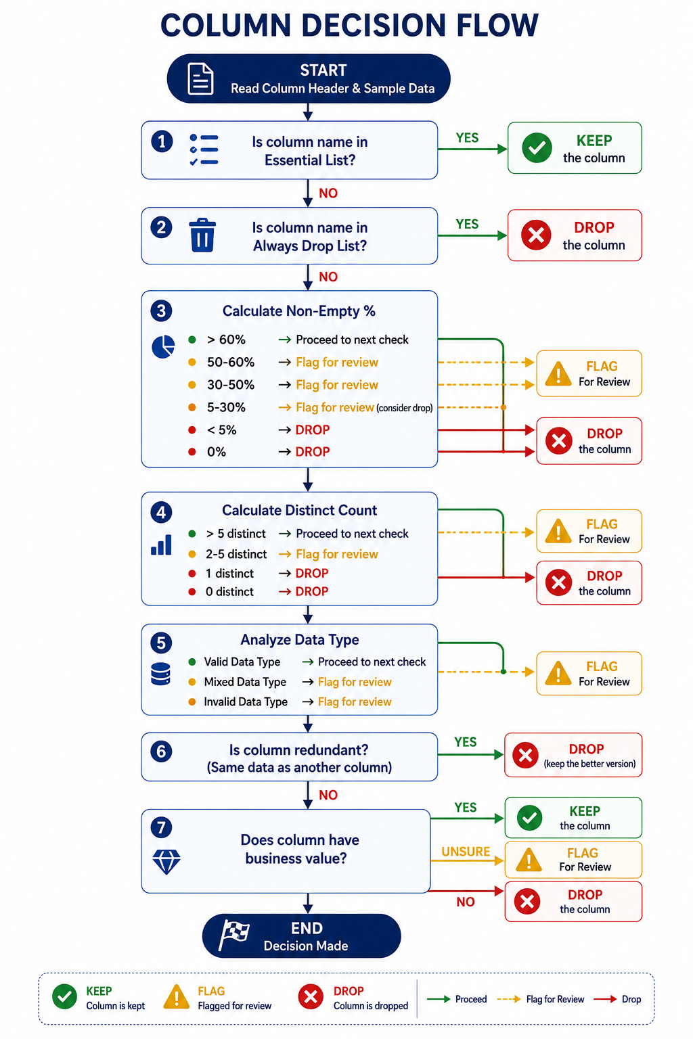
## 6.2 Decision Rules Summary

| Rule ID | Condition | Decision |
| :--- | :--- | :--- |
| R01 | Column is Essential | ✅ KEEP |
| R02 | Column is Always Drop | ❌ DROP |
| R03 | Non-Empty % > 60% and Business Value High | ✅ KEEP |
| R04 | Non-Empty % > 60% and Business Value Low | ⚠️ FLAG |
| R05 | Non-Empty % 50-60% and Business Value High | ⚠️ FLAG |
| R06 | Non-Empty % 50-60% and Business Value Low | ❌ DROP |
| R07 | Non-Empty % 30-50% and Business Value High | ⚠️ FLAG |
| R08 | Non-Empty % 30-50% and Business Value Low | ❌ DROP |
| R09 | Non-Empty % 5-30% and Business Value High | ⚠️ FLAG |
| R10 | Non-Empty % 5-30% and Business Value Low | ❌ DROP |
| R11 | Non-Empty % < 5% | ❌ DROP |
| R12 | Non-Empty % = 0% | ❌ DROP |
| R13 | Distinct Count = 1 | ❌ DROP |
| R14 | Distinct Count = 0 | ❌ DROP |
| R15 | Column is Redundant | ❌ DROP |
| R16 | Mixed Data Type | ⚠️ FLAG |
| R17 | PII Column | ✅ KEEP (secure) |

---

# SECTION 7: COMPLETE ERROR CATALOGUE

## 7.1 Column-Level Errors

| Error ID | Error Type | Description | Resolution |
| :--- | :--- | :--- | :--- |
| C01 | Pivot Artifact | Column from pivot table | ❌ Drop |
| C02 | Duplicate Column | Same data in multiple columns | ❌ Drop duplicates |
| C03 | All Null | Column with 100% missing values | ❌ Drop |
| C04 | Low Cardinality | < 2 distinct values | ❌ Drop |
| C05 | Vague Name | Column name has no meaning | ⚠️ Flag for review |
| C06 | Data Type Issue | Column has mixed data types | ⚠️ Flag for review |
| C07 | PII Column | Contains sensitive information | ✅ Keep (secure) |
| C08 | Non-Analytical | No business value | ❌ Drop |
| C09 | Calculated Field | Derived from other columns | ⚠️ Flag for review |
| C10 | Empty Column | All rows blank | ❌ Drop |
| C11 | High Empty % | > 60% empty | ❌ Drop |
| C12 | Medium Empty % | 30-60% empty | ⚠️ Flag for review |
| C13 | Low Empty % | < 30% empty | ✅ Keep (impute later) |
| C14 | All Identical | All values same | ❌ Drop |
| C15 | Binary Only | Only Yes/No values | ⚠️ Flag for review |
| C16 | Unique Values | Every row unique | ✅ Keep (identifier) |

---

## 7.2 Row-Level Errors

| Error ID | Error Type | Description | Resolution |
| :--- | :--- | :--- | :--- |
| R01 | Grand Total Row | Aggregated total row | ❌ Remove row |
| R02 | Blank Row | All cells empty | ❌ Remove row |
| R03 | Header Row | Column headers repeated in data | ❌ Remove row |
| R04 | Duplicate Row | Identical to another row | ⚠️ Flag for deduplication |
| R05 | Formula Row | Contains Excel formulas | ✅ Auto-calculate |

---

# SECTION 8: OUTPUT ARTIFACT

## 8.1 Column Optimization Report Format

| Original Column | Non-Empty % | Distinct Values | Data Type | Decision | Confidence | Reason |
| :--- | :--- | :--- | :--- | :--- | :--- | :--- |
| Student_ID | 100% | Many | Text | ✅ Keep | 100% | Primary identifier |
| Name | 98% | Many | Text | ✅ Keep | 100% | Student identity |
| Age | 92% | Many | Mixed | ✅ Keep | 90% | Demographics (needs cleaning) |
| Gender | 90% | 3 | Text | ✅ Keep | 100% | Demographics |
| Email | 95% | Many | Text | ✅ Keep | 100% | Contact |
| Phone | 88% | Many | Text | ✅ Keep | 100% | Contact |
| City | 95% | Many | Text | ✅ Keep | 100% | Geography |
| Course | 90% | 8 | Text | ✅ Keep | 100% | Core analysis |
| Branch | 88% | 12 | Text | ✅ Keep | 100% | Core analysis |
| Semester | 85% | 8 | Numeric | ✅ Keep | 100% | Core analysis |
| Marks | 95% | Many | Numeric | ✅ Keep | 100% | Performance |
| CGPA | 55% | Many | Numeric | ✅ Keep | 80% | Performance (impute later) |
| Attendance_% | 95% | Many | Numeric | ✅ Keep | 100% | Engagement |
| Status | 100% | 2 | Formula | ✅ Keep | 100% | Academic status |
| Admission_Date | 95% | Many | Date | ✅ Keep | 100% | Timing analysis |
| Fees_Paid | 25% | Many | Mixed | ⚠️ Flag | 60% | Financial (needs cleaning) |
| Backlogs | 20% | Many | Numeric | ⚠️ Flag | 60% | Academic (needs imputation) |
| Guardian_Name | 15% | Many | Text | ⚠️ Flag | 50% | Optional |
| Column1 | 0% | 0 | Empty | ❌ Drop | 100% | Completely empty |
| Analysis | 0% | 0 | Empty | ❌ Drop | 100% | Completely empty |
| Row Labels | 100% | Many | Text | ❌ Drop | 100% | Pivot artifact |
| Sum of Marks | 100% | Many | Numeric | ❌ Drop | 100% | Pivot artifact |
| Count of Attendance_% | 100% | 1 | Numeric | ❌ Drop | 100% | Pivot artifact |
| Grand Total | 100% | 1 | Text | ❌ Drop | 100% | Pivot artifact row |

---

## 8.2 Summary Statistics

| Metric | Value |
| :--- | :--- |
| Original Columns | 24 |
| Columns Kept | 13 |
| Columns Flagged | 4 |
| Columns Dropped | 7 |
| Optimization Rate | 46% reduction |

---

# SECTION 9: INTEGRATION WITH CLEANING PIPELINE

## 9.1 Updated Pipeline Order

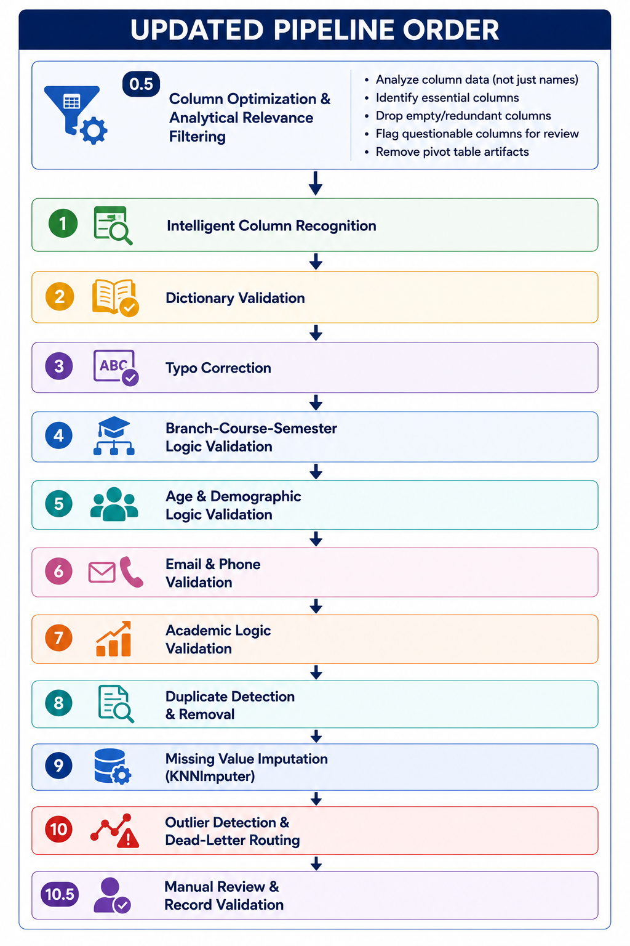
## 9.2 What Gets Passed to Stage 1

| Column Category | Columns Passed |
| :--- | :--- |
| **Identity** | Student_ID, Name |
| **Demographics** | Age, Gender, City, State |
| **Contact** | Email, Phone |
| **Academic** | Course, Branch, Semester, Marks, CGPA, Attendance_%, Status |
| **Timing** | Admission_Date |
| **Flagged** | Fees_Paid, Backlogs, Guardian_Name (for review) |

---

# SECTION 10: SUMMARY CHECKLIST

| Aspect | Covered? |
| :--- | :--- |
| Analyze data content, not just column name | ✅ |
| Emptiness thresholds (0%, <5%, 5-30%, 30-60%, >60%) | ✅ |
| Cardinality analysis (1, 2-5, >5 distinct values) | ✅ |
| Data type analysis | ✅ |
| Redundancy detection | ✅ |
| Pivot table artifact detection | ✅ |
| Business value analysis | ✅ |
| Essential columns identification | ✅ |
| Always drop columns identification | ✅ |
| Flag for review criteria | ✅ |
| Complete decision matrix | ✅ |
| Confidence scoring | ✅ |
| Output report format | ✅ |
| Pipeline integration | ✅ |

---

# SECTION 11: EXAMPLE EXECUTION (Case Study)

## 11.1 Original Dataset

| Column Name | Sample Data | Non-Empty % | Distinct | Decision |
| :--- | :--- | :--- | :--- | :--- |
| Student_ID | STU1000... | 100% | Many | ✅ Keep |
| Name | Saksham Sem... | 98% | Many | ✅ Keep |
| Age | 23, 20, -5, 120 | 92% | Many | ✅ Keep |
| Gender | Male, Female | 90% | 2 | ✅ Keep |
| Email | umangshetty@... | 95% | Many | ✅ Keep |
| Phone | 6379146484... | 88% | Many | ✅ Keep |
| City | Sri Ganganagar... | 95% | Many | ✅ Keep |
| Course | MBA, CSE, ECE... | 90% | 8 | ✅ Keep |
| Branch | CSE, ECE... | 88% | 12 | ✅ Keep |
| Semester | 1, 2, 3... | 85% | 8 | ✅ Keep |
| Marks | 70, 80, N/A... | 95% | Many | ✅ Keep |
| CGPA | 8.5, 7.5... | 55% | Many | ✅ Keep |
| Attendance_% | 58.74, 53.81... | 95% | Many | ✅ Keep |
| Status | Formula | 100% | 2 | ✅ Keep |
| Admission_Date | 2024-07-28... | 95% | Many | ✅ Keep |
| Fees_Paid | One Lakh, -5000... | 25% | Many | ⚠️ Flag |
| Column1 | (empty) | 0% | 0 | ❌ Drop |
| Analysis | (empty) | 0% | 0 | ❌ Drop |
| Row Labels | STU1000... | 100% | Many | ❌ Drop |
| Sum of Marks | 70, 80... | 100% | Many | ❌ Drop |
| Count of Attendance_% | 1, 1... | 100% | 1 | ❌ Drop |
| (blank) | Grand Total | 100% | 1 | ❌ Drop |

## 11.2 After Stage 0.5

| Column Name | Decision |
| :--- | :--- |
| Student_ID | ✅ Keep |
| Name | ✅ Keep |
| Age | ✅ Keep |
| Gender | ✅ Keep |
| Email | ✅ Keep |
| Phone | ✅ Keep |
| City | ✅ Keep |
| Course | ✅ Keep |
| Branch | ✅ Keep |
| Semester | ✅ Keep |
| Marks | ✅ Keep |
| CGPA | ✅ Keep |
| Attendance_% | ✅ Keep |
| Status | ✅ Keep |
| Admission_Date | ✅ Keep |
| Fees_Paid | ⚠️ Flag |
| Column1 | ❌ Drop |
| Analysis | ❌ Drop |
| Row Labels | ❌ Drop |
| Sum of Marks | ❌ Drop |
| Count of Attendance_% | ❌ Drop |
| (blank) | ❌ Drop |

---

**This is the complete Stage 0.5 Specification. Every possible column optimization problem is documented with a clear, deterministic approach — without a single line of implementation code.**

